Homework 8

2017329621055 黄浩然

1. Derive and simplify the path expression for the flow graph in Figure 2.12.

(let edge 1-2:a, 2-3:b, 3-4:c,3-11:d, 4-5:e, 4-10:f, 5-6:g, 6-10:h, 6-7:i, 7-8:j, 8-10:l, 7-9:m, 9-6:n,10-3:o)

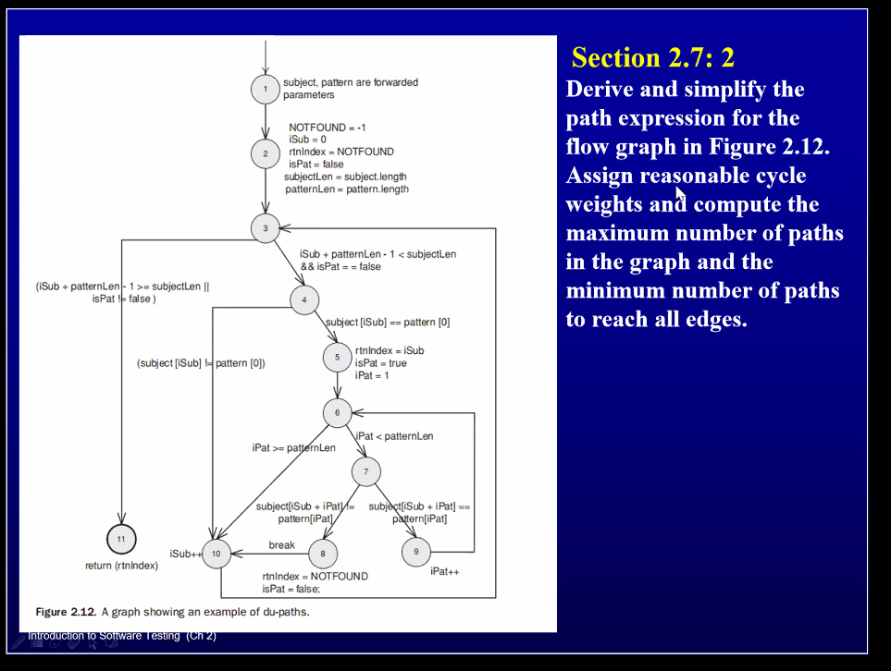

ab(cf+(eg+inm)\*h+ijl)\*o d

1. Let edge n=2, o=3:

Max: 1(2+7)\*40\*1= 360

1. 7